Linear Algebra

Laboratory Activity No. 8

**System of Linear Equations**

|  |  |
| --- | --- |
| *Submitted by:* | *Instructor:* |
| Guy, Lawrence Adrian B. | Engr. Dylan Josh D. Lopez |

December 21, 2020

# Objectives

The objective of this laboratory activity is to familiarize students with the system of linear equations. After this activity, students would be able to solve word problems using linear equations. Students would also be able to program the system of equations using Python.

# Methods

The practice of the activity is to solve word problems by implementing linear equations in Python to solve the problems. By doing so, students will be able to solve problems using the system of linear equations but also learn to implement them in Python.

The deliverable of the activity is to create a word problem with a minimum of two equations. The deliverable is achieved by representing linear equations into matrices and using NumPy functions to solve the created word problem.

# Results

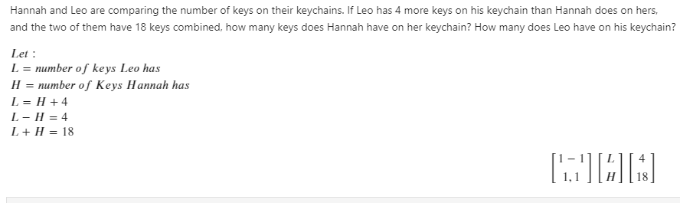

Figure 1 Created problem for Lab 8.

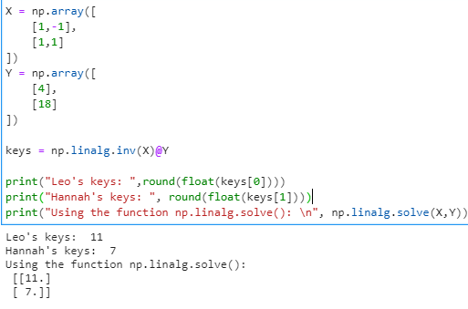

Figure 2 Codes and output of Lab 8

Figure 1 shows the created problem for this activity while figure 2 shows the codes and output to solve the word problem in figure 1. The equations and are transformed into matrices so that the problem would be solved by using NumPy functions. As seen in figure 2, by getting the inverse of matrix X then multiplying it to the matrix Y, the answer is found. Comparing the answer from the formula given to the built-in NumPy function np.linalg.solve(), the answer is the same. The function np.linalg.solve() computes for the exact solution in the system of linear equation [1]. That’s why the answer is the same as the given formula.

# Conclusion

The laboratory activity discussed the system of linear equations and the implementation of it in programming in Python. The system of linear equations is used for finding the values of several unknowns in a set of two or more equations. Through elimination and isolating an unknown variable, we can use that to solve for the value of that single unknown variable. By doing so, we can substitute the value that we got into the equation to find the other unknowns. Finally, we can check if the values that we got are correct by substituting them to the equation. And if the values are correct it would then satisfy the equation.

Linear equations can be used in many ways. One of its uses is in robotics. The robots can move from one place to another or moves in place. These movements can be computed using matrix operations. An example would be a robot am. Homogeneous transformation matrix is used to describe the movement and rotation of the robot arm [2].

**References**

[1] NumPy, “numpy.linalg.solve,” 2020. https://numpy.org/doc/stable/reference/generated/numpy.linalg.solve.html (accessed Dec. 19, 2020).

[2] T. Bower, “Coordinate Transformations in 2-D.” http://faculty.salina.k-state.edu/tim/robotics_sg/Pose/coordTrans2d.html#:~:text=The transformation matrix is found,to the world coordinate frame. (accessed Dec. 21, 2020).

**Appendix**

Github Repository Link:

https://github.com/Loreynszxc/Linear-Algebra-Lab-8